Experiment: 10

5G Network Slicing Environment Using MATLAB

Aim
To analyze the performance of a 5G Network Slicing environment by studying the number of network slices, slice utilization, and end-to-end latency using MATLAB.
Objectives
Objective – 1: Analyze the Number of Network Slices
Analyze the creation and allocation of multiple network slices in a 5G network using MATLAB. Observe how different slices can be configured to support diverse service requirements and
applications.
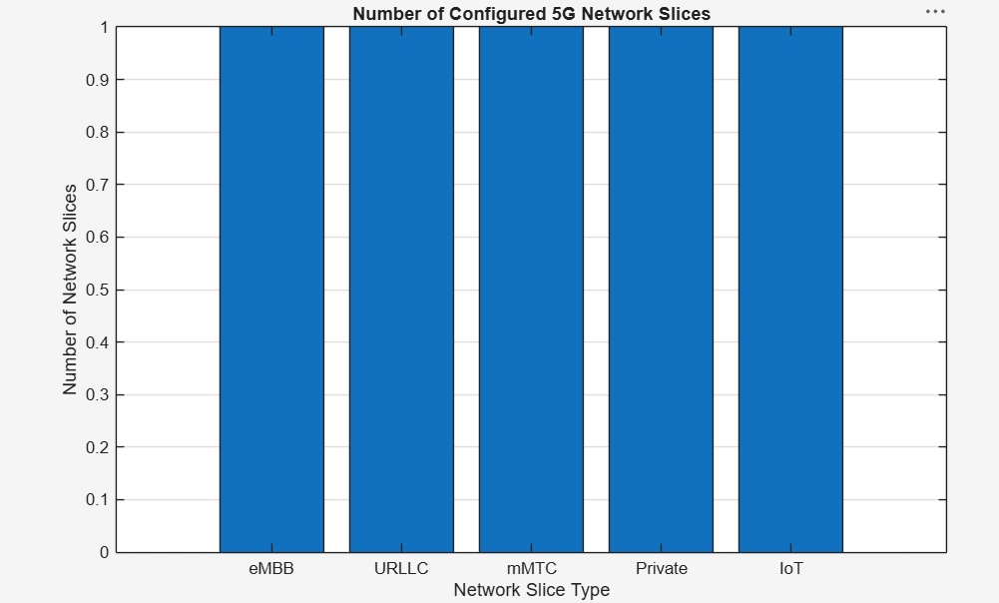

Objective – 2: Compare Slice Utilization (%)
Compare the utilization of different network slices using MATLAB. Analyze how efficiently network resources are allocated and utilized across multiple slices.
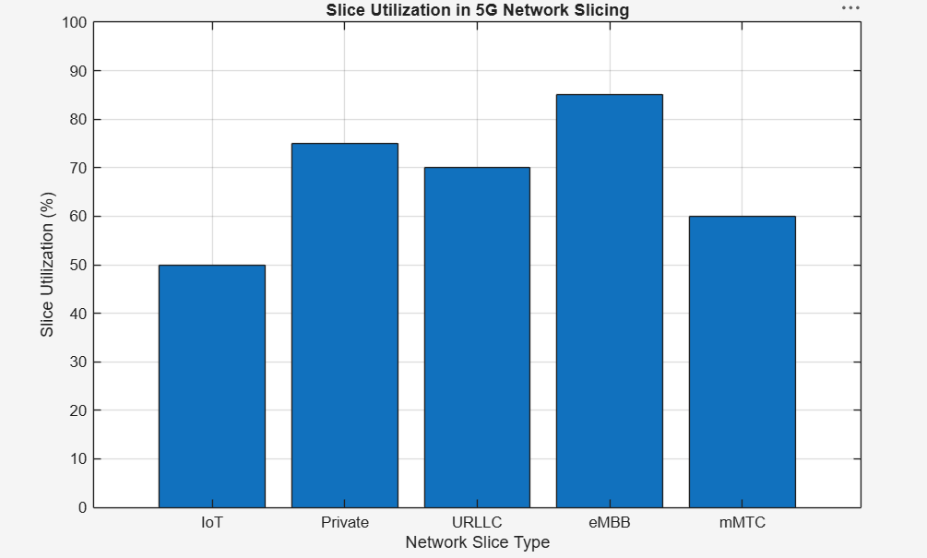

Objective – 3: Analyze End-to-End Latency (ms)
Analyze the end-to-end latency of different network slices using MATLAB. Compare the latency values to understand the Quality of Service (QoS) requirements of various 5G applications.
